BCOE Purchase Orders with Receiving
Inventory and Asset Training – February, 2020

Annual Inventory (completed by May 1st)

For all inventory assets, the following fields must be completed:
- Status
- Tag #
- Status Comment* (condition – defined as: Excellent, Good, Fair or Poor)
- Department
- Responsibility Code (manager code)
- Location
- Room
- Group
- Asset Category
- Description
- Model and Serial # (if applicable)
- Unit Cost

Completing as many fields as possible during the requisition and receiving process decreases the amount of data entry needed for inventory.

Creating a Purchase Order with Receiving
When creating a vendor requisition, enter “PO with Receiving” in the Vendor Information, Order Type field. Submit the requisition for approval and print the purchase order.

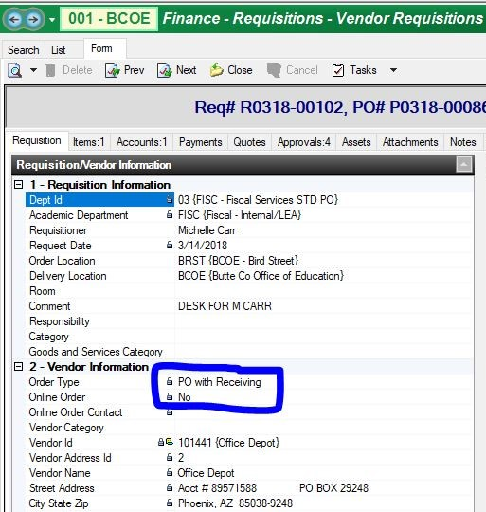

Receiving Process

When the inventory asset is received:

- Login to Escape
- From the activity tree, select:
FINANCE PURCHASING RECEIVE PO ITEMS
- For each receipt, enter:
- Date Received
- Reference Number (Requisition or Purchase Order numbers)
- Receive All – Yes or No
(Select Yes if your order is complete, No if there are additional items outstanding)
- When all fields have been completed, select Go.

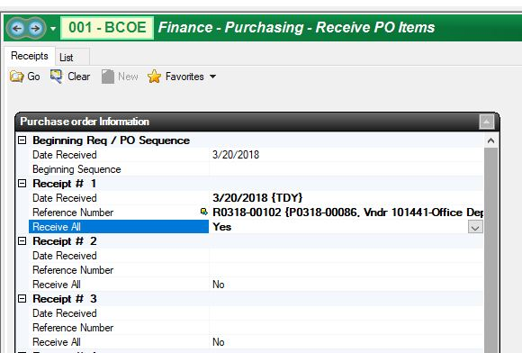

Based on the reference numbers previously entered, ESCAPE will compile a list of purchase orders with inventory assets waiting to be received.
- Enter the number of items you are receiving in the Receive Now field, or verify that it is 1 for a single item.
- Select Yes in the Create Asset field – this will make Asset Group and Asset Category fields mandatory.
- Select the appropriate Asset Group and Asset Category from the drop-down menu.

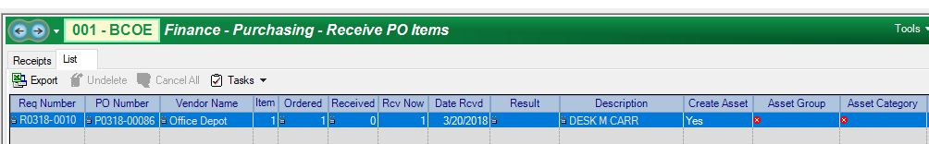

- Enter the Manufacturer, Model # and Serial # - N/A if not applicable.
- Enter the responsible employee into the Employee field, by employee ID #.
Note: Any employee changes beyond initial assignment must be made through Financial Services.
- Enter any notes, if applicable.

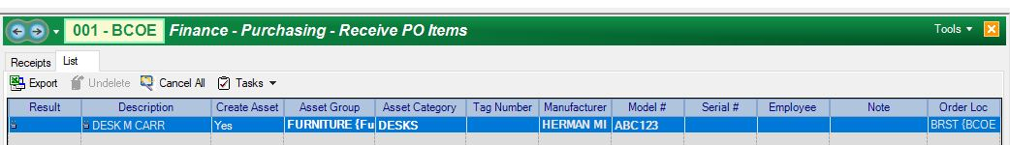

- When all fields have been completed, select TASKS POST

Updating Inventory
Now that the Inventory Asset has been received, the status needs to be updated from Pending to Active and additional information must be entered.

- From the activity tree, select:
FINANCE ASSETS ASSET PHYSICAL INVENTORY
- Search for the record by entering today’s date (TDY) in the Receipt Date field, under Purchase Information, and select Go.
- Change the Status field from P (Pending) to A (Active).
- Update the Room, Department, Tag Number and Responsibility fields if needed. Check for any other fields that may need to be updated.
- When all fields have been completed, select TASKS POST

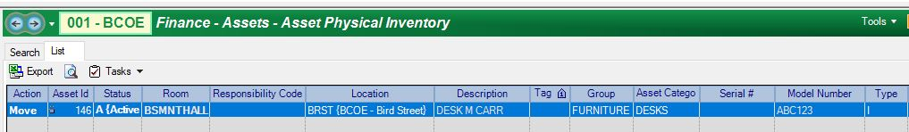

Fixed Assets Module (Read Only)
All information for Inventory Assets can be found in the Fixed Assets module:

- From the activity tree, select:
FINANCE ASSETS FIXED ASSETS
- Search for the record by entering the Asset ID Number.
- Tabs include Asset Summary, Accounts, Attachments, Notes and History.
(Note: Depreciation and Related To are N/A)

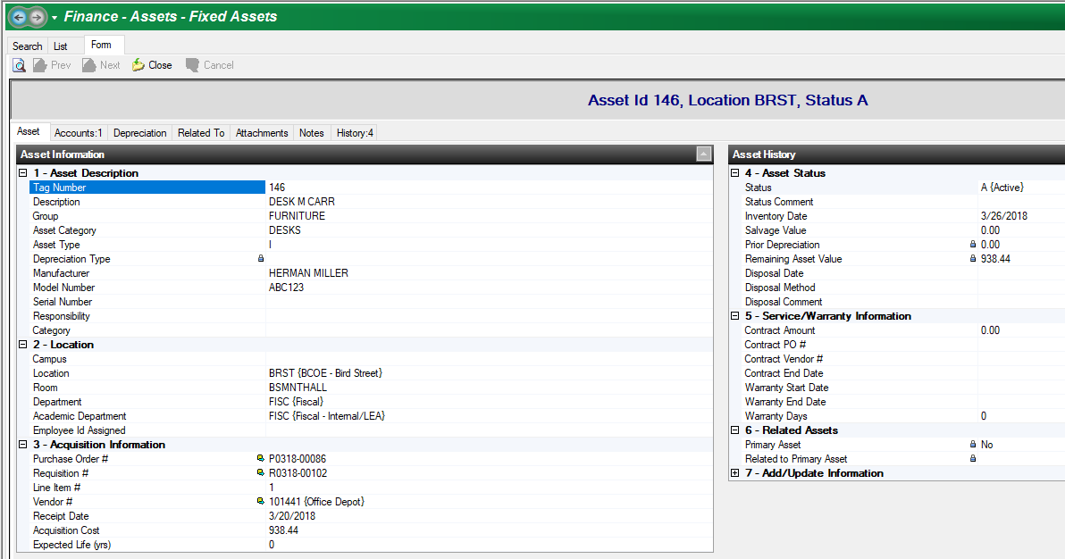

Inventory Asset Disposal Form (BSF-100)

Additional information regarding inventory asset disposal can be found on the BCOE website:

BCOE DOCUMENTS
Operating Procedures Disposal Operating Procedure

